0.5. Transformations of functions.
Algebraic operations on functions: Let and be real functions with domains and respectively, such that , and . Then we dfine the following:
- .
- .
- .
- .

Example 5.1 (1).
Domain | Functions

(2)
Domain | Functions

Composition of Functions: Let and be real functions. We define the composition of and as and the domain of is .
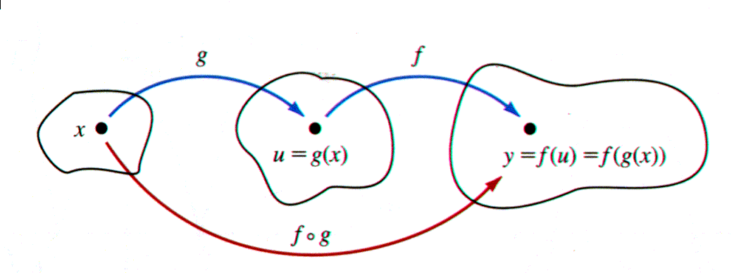

Example 5.2.

Domain | composition | Functions

Remark: It is not necssary that .

Example 5.3. Let . Then
Note that .

Equations of straight lines: An equation of a straight line is an equation in and whose graph in the plane is a line.

- Slope of a line: The slope of a nonvertical line is defined as the ratio
for any two distinct points on .

Example 5.4. The slope of a line that passes through the points and is

- The general line equation (slope-intercept) form: The general line equation of a line with intercept and slope is of the form:
Here the line intercept axis at the point .

Example 5.5. Find the line equation intercept the axis at the point and has slope .
Solution. We have . Thus the line intercept equation is .

- Horizontal lines : The horizontal line equation is , where, . This line is parallel to axis.This line has slope zero. Here the horizontal line passes through the point .
Example 5.6. Find an equation of the line passes through the point .
Solution. The line equation is .
- Vertical line equation: The vertical line equation is , where, . This line is parallel to axis. This line has no slope. Here the vertical line passes through the point .

Example 5.7. Find an equation of the line passes through the point .
Solution. The line equation is .

- The equation of a line passes through a fixed point with slope is .
Example 5.8. Find an equation of the line passes through the point and has slope .
Solution. We have and . The line equation is

- The equation of a line passes through the fixed points and is
Example 5.9. Find an equation of the line passes through the points .
Solution. We have and . The line equation is

- The line equation intercept form: An equation of a line passes through the points is of the form:

Example 5.10. Find an equation of the line passes through the points and .
Solution. We have and . Thus the line equation is :

- The lines
  - Parallel if and only if .
  - Prependicler if and only if .

Example 5.11. Find an equation of the line passes through the point and prependiclar to the line .
Solution. The line equation gives
and the required equation is
Example 5.12. Find an equation of the line passes through the point and parallel to the line .
Solution. The line equation gives
and the required equation is
Remark. If the slope of two lines are the same, then the point must be collinear. are
Example 5.13. Determine the points and are colinear.
Solution. The slope of the line joining the points and is
The slope of the line joining the points and is
Since the slopes are the same, the point are collinear.

Solved Problems

- If , then find .
Solution.
- If , then find .
Solution.
is undefined.

- If , then find .
Solution.

- If , then find .
Solution.
is undefined.

- Find the domain of the following:
 | Reasons | The function

- Find the domain of .
Solution.

interval
 | - - - | - - - | + + + | - - - | - - -
 | + + + | - - - | - - - | - - - | + + +
 | + + + | - - - | - - - | + + + | - - -
 | + + + | + + + | + + + | + + + | + + +
Thus the domain .

- Find the domain of .
Solution. We note that . So or . Thus .

- Find the domain of .
Solution. We note that . So .

- Find the domain of .
Solution. We note that . So and . Hence .

- If , then find and the domain of each one.
  - . The function is defined when . Thus .

  - . The function is defined when . Thus .

  - . The function is defined when . Thus .

  - . The function is defined when . Thus .

  - .
  - .

  - .

- Find from the following .
Solution . .

Unsolved Problems

1) Find the domain of the function.

Reason
radical function
radical function

2) Determine whether the function even, odd , or neither.
Type
odd
even
even
Neither even nor odd
odd
Neither even nor odd
odd
Neither even nor odd

3) Find and the domain.
Domain | Function

domain | function

4) Mark the correct Answer.
(i) The domain of is :
a) b) c) d) e) non of these
Ans. a ).

(ii) If and , then :
a) b) c) d) e) non of these
Ans. b ).

5) Find the domain of the following:
Solution | Problems
 |  | 1
 |  | 2
 |  | 3
 |  | 4
 |  | 5
 |  | 6

- Find and the domain.
م | Domain | composition | function
2

7) Find the slope of the line passes through the points .
- Slope : .

8) Find the equation of the line passes through the point and parallel to the line .
- The equation is .
9) Find the equation of the line passes through the point and perpendicular to the line .
- The equation: .

  - Draw the following intervals on the real line :
a) b) c) d) .

  - Use intervals to describe the inequlities:
a) b) c) c) .

  - Let . Find

  - Let . Find , and .

  - Let .

Find .

(15) Find and the domain.
1)
Sol: ,
(2)
Sol: ,
(3)
Sol: ,

- Find the slope of the line through the points:
(1) (2)

- Find a second point on the line with given slope>
(1) (2)
(3)

- Determine if the lines are parallel, perpendicular, or neither:
(1)
(2)
(3)
(4)

- Find an equation of a line through the given point and
  - Parallel and (b) perpendicular to the given line
(1)
(2)
(20) Determine if the pints are collinear.
(1) and
(2) and

Math 110 (Calculus) workdho
Name: No.:
E-mail: Prof_h_abujabal@yahoo.com
MSN: Prof.h.abujabal@hotmail.com Mobile: 0505650409
- The function is a
Polynomial Cubic Radical Rational
- The function is a
Linear Cubic Radical Rational
- The function is a
Linear Cubic Power Quadratic
- The function is
Linear Cubic Power Quadratic
- The function is a
Linear Cubic Power Quadratic
- The function is a
Linear Cubic Power Quadratic
- If , then
- If , then
- If , then
- If , then
- If , then
- If , then
- If , then

- Let , and . Then is
- Let , and . Then is
- Let , and . Then is
- Let , and . Then is
- Let , and . Then is
- The equation of the line passes through the point with slope is
- The slope of the line parallel to the line is
- The slope of the line perpendicular to the line is
- The equation of the line passes through and is
- Let . Show that is a f unction.

- Let . Find
- Let . Find
(b)
3. Draw the interval .

I s ?
- Draw the interval .

Is ?
- Find the slope of the line passes through the points and .

- Find the line equation with slope , and passes through the point .

- Find the equation of the line passes through the points and .

- Find the slope of the line parallel and perpendicular to the line .

- Find the equation of the horizontal line passes through .

- Find the equation of the vertical line passes through .

